|  |
| --- |
| **NAMA : AHMAD WAHYU ZIYADIN A** |
| **NIM : 1207070009** |
| **KELAS : PCD TT** |
| **TUGAS KE-5** |

1. Percobaan 1

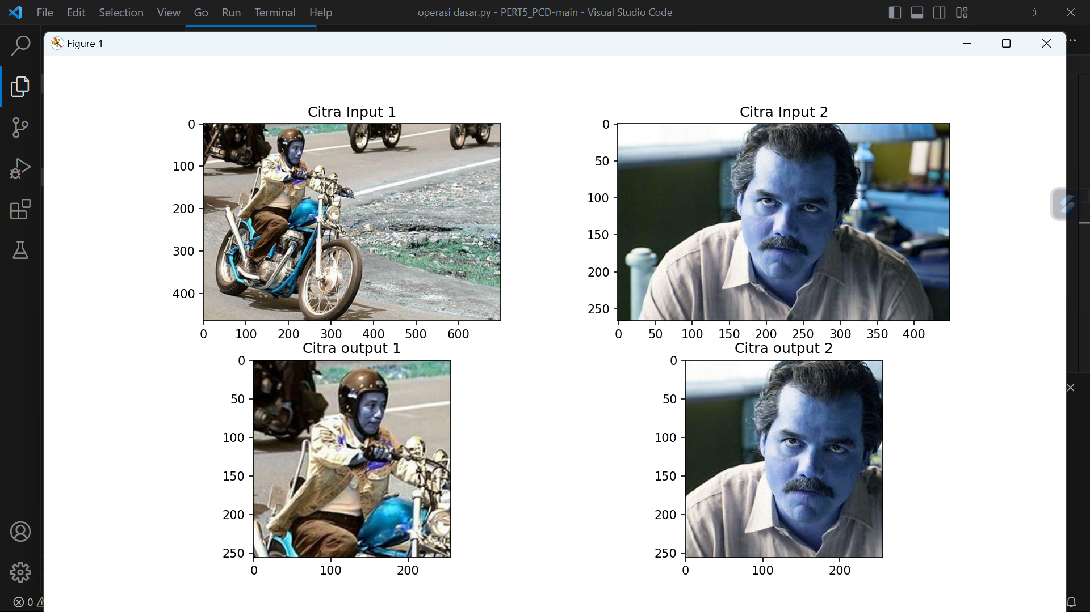

1. Percobaan 2

* 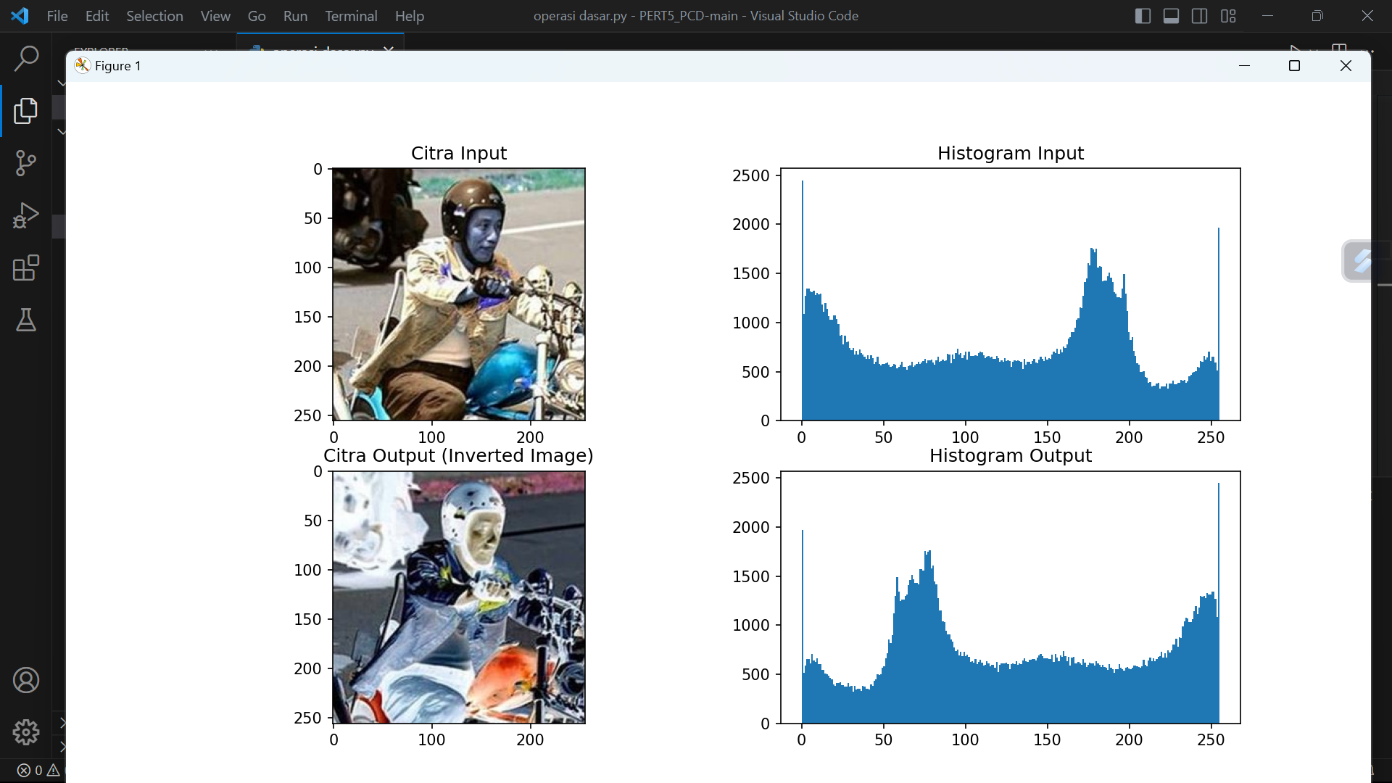
* 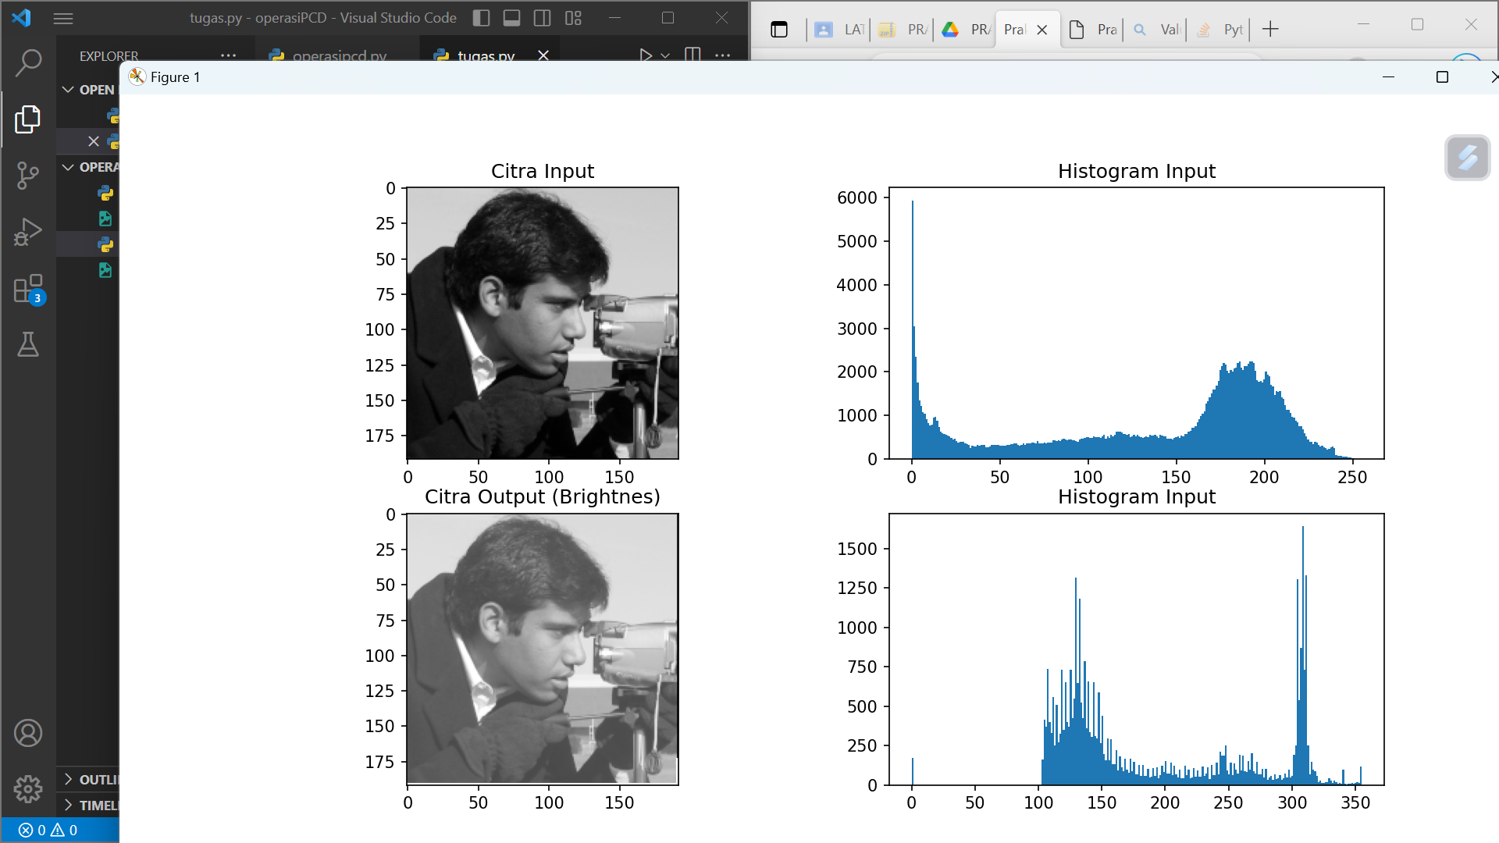

1. Percobaan Brightness,Contrass,Autolevel contrass

* 
 